Opening Prayer Service

Gather

Gracious God, we gather today around this table to give you thanks and praise and to remember all the people in our country and world who do not have a place at the table. So many of your people do not have the food they need to survive. They don’t have a table or a place at anyone else’s table. Tables are where we come together to share a meal. But they also are where people gather to make important decisions about their families, their neighborhoods and nations, and their world. Too many people have no place at these tables, so their voices and needs are never heard.

Open our hearts and minds to the reality of poverty in our land. Help us to hear the voice of Jesus Christ in the cry for help that rises from this world of poverty. Inspire us to build a world free of poverty and injustice. Amen.

Listen

Isaiah 58:6-11 (Share your bread with the hungry)
Luke 4:16 – 19 (Mission of Jesus)
Luke 7:20 – 22 (Report to John the Baptist)

Respond

Let us pray for those in need . . .

Defender of the oppressed and the orphan, we pray for all people in our nation and world who suffer from poverty, injustice, and fear.
Response: In your tender mercy, protect them, O Lord.

We pray for all those without enough food to eat today and for those without a home.
Response: In your tender mercy, provide for them, O Lord.

We pray for those who work long hours but cannot earn enough money to support their families.
Response: In your tender mercy, encourage and strengthen them, O Lord.

We pray for babies born at risk, for children who are sick, and for all those who lack proper health care.
Response: In your tender mercy, help and sustain them, O Lord.

We pray for families facing loss of jobs or the anxiety of an uncertain future.
Response: In your tender mercy, give them hope, O Lord.

Go Forth

O God, you are the defender of the poor
and the stronghold of the orphaned and the widowed.
When your people were robbed of their homes
and put in chains,
you did not abandon them
but made of them a special people.
From the remnants of their lives
you fashioned them into a garment of joy.
In the fullness of time, you sent Christ
who announced the good news of salvation to the poor,
the day of liberty for those in need.
In these days, the nightmare of poverty
haunts our world and enters our homes.
Standing in lines, deprived of human dignity,
the poor of our world beg for love
and ask for food and work.
Shine your spirit of courage and compassion upon us.
Warm the cold of our hearts and wills.
Help us to help your beloved poor.
Help us to see that in loving and tending their needs
we are tending the presence of Christ among us.
We ask this through Christ and the Holy Spirit,
with you, One God, forever and ever.
Amen.

(Act Justly, Love Tenderly, Walk Humbly: Prayers for Peace and Justice, Edward Gabriel)

Handout #2.

Script for Who Are the Poor?
Most people in North America have what they need to live in comfort. Most people have enough food to eat, enough clothes to wear, and enough shelter to be safe.

People are said to be “living in poverty” when they do not have enough of what it takes to fulfill basic human needs. A person can be poor when he or she lacks the essentials of daily life, such as sufficient food to keep them from being hungry. A person can be poor if he or she works hard at a job but doesn’t make enough money to buy the things needed to be healthy and secure, such as proper clothing to keep them warm in cold weather, or health care to help them recover from illness.

So, who are the poor in North America? This is how those living in poverty would answer if they were here today:

We are mostly White,
but also African American, Latino, Native American, and Asian too.
We are children.
We are the elderly.
We are disabled.
We live in cities,
suburbs,
and in the country.
We go to work
and to school
and to church.
We want a good and safe life for our families and ourselves; we are concerned about raising our children well.
We help others who are in even worse shape than ourselves.
Some of us are single mothers with children, whose husbands left us after years of marriage, and we are now working minimum wage jobs.
Some of us are teenagers who already have a child.
Most of us can’t make ends meet even though we work full time.
Most of us don’t have health insurance, even if we are working full time.
Some of us have no jobs because the companies in our area moved our jobs to other countries.
We are people who frequently depend on handouts at food pantries and soup kitchens.
Most of us did not receive a good education from our parents and our schools.
Some of us messed up our lives with alcohol and drugs.
If we were a state or province, our population would be greater than that of California. We would, in effect, be the largest state in the U.S.
We are nearly one in six of all Americans.
And we aren’t all the same.

Handout #3.

Living Month to Month

Life Situation 1:
Monthly Income for a family of four at the poverty level: $_____ (approximately).

Life Situation 2:
Monthly income for a single-parent mother and two children with one child in day care and one in school: $_____ (approximately).

Life Situation 3:
Monthly Income for a single person working 40 hours at the minimum wage: $_____ (approximately).

Life Situation 4:
Monthly Income for an individual senior citizen on a fixed income of Social Security after the Medicare deduction: $_____ (approximately).

Expense Category Monthly Allotment

Rent ________________

Utilities—heating and cooling (electricity, gas/oil, water) ________________

Food ________________

Phone ________________

Education ________________

Childcare for children under 5 years old ________________

Transportation
auto (monthly payment, repairs, insurance) ________________
public transportation ________________

Clothing ________________

Medical and dental (prescriptions, doctor visits) ________________

Insurance (house, health, life) ________________

Entertainment (eating out, movies, books, devices) ________________

Recreation ________________

Church/charitable gifts ________________

Handout #4.

Budget Items

Rent  $ | Utilities  $
Food  $ | Food  $
Phone  $ | Education  $
Child Care  $ | Transportation  $
Clothing  $ | Medical and Dental  $
Insurance  $ | Entertainment  $
Recreation  $ | Church/Charitable Gifts  $

Handout #5.

Why Are People Poor Instruction Sheet

Step 1

- Read all of the poverty cards.
- Arrange the cards in a circle on your large sheet of paper. The card headed “poverty” should be at the top of the circle, and all of the others should follow it in a clockwise order. The arrangement should show how each condition is created or caused by the one that precedes it.
- When your family has agreed on an arrangement, glue the cards onto the paper and draw arrows from the first card around until the circle is completed.

Step 2

- Share your poverty chart with the other families in your group, explaining why you placed the cards in the order you did.

Step 3

- As a family, develop specific ideas for breaking the cycle of poverty. Imagine you have the power to change the situation of people, especially children, who live in poverty. Start with ideas from the children.
- Write all of the ideas.

Step 4

- Select several ideas that will address a particular issue on your poverty chart. Add them to your poverty chart, writing the idea next to the step on the poverty cycle to which it corresponds.

Step 5

- Discuss the following questions:

- How are we feeling about the situation of others who live in poverty today? Is it hard for us to believe that so many people are living in poverty in the richest country in the world? What surprised us about the situation?
- Why does poverty continue?
- What would it be like if several of our family’s ideas were actually implemented? What impact would our ideas have on people’s lives?
- What did we learn today that we didn’t know before?

Handout #6.

Poverty Cards

Poverty  Thirty-seven million Americans and one in every six children (13 million children) live in poverty. | Work Skills  Children who have difficulties in school, miss a lot of school, or drop out of school may not learn skills they will need to get a job, skills such as reading, writing, or math.
Hunger  Children who live in poverty often don’t get enough food to eat, or don’t eat enough nutritious foods. One in six children in the United States experiences hunger or is at risk of hunger. | Not Enough Income  People who have no work, or too little work, or do not get paid well enough for the work they do, cannot earn enough money for their basic needs: food, clothing, shelter. Their children are then born into a situation of poverty.
Unemployment  When children grow older, they look for work. If they have not learned basic skills in school, they may have trouble finding a job or finding a job that pays them enough. | Malnutrition  Children who do not get enough food to eat can, over time, become malnourished and fail to grow and develop.
Health  Children who are poor may become ill more often because their bodies are not strong enough to fight off infections. Very often these children live in families who do not have medical insurance or money to visit the doctor. 26.1 million Americans, which is 8% of the population, do not have health insurance. | School  Children who are poor and often ill may find it difficult to learn and may miss a lot of school. Most children who are poor attend schools that do not provide a quality education.

Handout #7.

People Are Poor Because….

From the following list, choose the three responses you think best describe why people are poor in North America.

People are poor because:

- They are lazy and do not work hard enough to earn what they need.
- They do not have work (unemployment).
- Even though they work hard, they do not earn enough money to buy what they need (wages are too low).
- They do not have enough education or job skills.
- They have too many children.
- They are discriminated against (treated unfairly) because of their color, race, nationality, religion, sexual orientation, or gender.
- The government ignores the needs of the poor.
- They get sick and need medical care more than other Americans.
- They do not have enough initiative (people just sit back and wait for things to happen).
- There really is no reason in particular. That’s just the way the world is.
- There are too many needs in the world and not enough resources to meet them all.
- They experience natural disasters such as floods or earthquakes and can’t recover and rebuild.
- There are enough resources in the world for everyone to have what they need, but these resources are not shared fairly.
- There is too much money spent on military weapons and not enough on ensuring that people have the basic necessities of life.
- The resources of our country (food, water, land, energy) are being wasted, rather than being used for what people need.
- Too many businesses are moving jobs to other countries and not generating enough good paying jobs for people in our country.

Other reasons (list any you can think of):

Handout #8.

Poverty in the United States
(U.S. Census Bureau, 2020; www.census.gov/hhes/www/income.html)

A Quick Quiz
- According to the 2020 Census report, 37.2 million people live in poverty in the United States.
- The number of people living in poverty decreased in 2020.
- The United States government says that a family of four is poor if its income is less than $35,000 a year.
- Over six million people were considered the “working poor” in 2019.
- More children than seniors live in poverty.

A Poverty Profile
U.S. Population: 331,449,281 million (2020 estimate)

- The official poverty rate in 2020 was 11.4 percent, up 1.0 percentage point from 10.5 percent in 2019. This is the first increase in poverty after five consecutive annual declines.
- In 2020, there were 37.2 million people in poverty, approximately 3.3 million more than in 2019.
- Between 2019 and 2020, the poverty rate increased for non-Hispanic Whites and Hispanics. Among non-Hispanic Whites, 8.2 percent were in poverty in 2020, while Hispanics had a poverty rate of 17.0 percent. Among the major racial groups examined in this report, Blacks had the highest poverty rate (19.5 percent), but did not experience a significant change from 2019. The poverty rate for Asians (8.1 percent) in 2020 was not statistically different from 2019.
- Poverty rates for people under the age of 18 increased from 14.4 percent in 2019 to 16.1 percent in 2020. Poverty rates also increased for people aged 18 to 64 from 9.4 percent in 2019 to 10.4 percent in 2020. The poverty rate for people aged 65 and older was 9.0 percent in 2020, not statistically different from 2019.
- Between 2019 and 2020, poverty rates increased for married-couple families and families with a female householder. The poverty rate for married-couple families increased from 4.0 percent in 2019 to 4.7 percent in 2020. For families with a female householder, the poverty rate increased from 22.2 percent to 23.4 percent. The poverty rate for families with a male householder was 11.4 percent in 2020, not statistically different from 2019

Several Key Causes of Poverty
- Even if they want to work, people in poverty often can’t find jobs with decent pay and benefits. Millions of American workers earned an hourly wage too low to adequately support a family of four.
- If they can’t work (by reason of physical/psychological disability or age), they don’t have enough money from their personal resources or from government assistance to cover their expenses.
- The minimum wage, for those who earn it, has not kept pace with inflation over the past fifty years. The purchasing power of earnings has declined.
- Ex-spouses fail to pay court-ordered child support to female heads of households. Moreover, the value of child support payments has not kept pace with inflation.
- The poor’s share of our nation’s wealth is too small and declining. The rich do get richer and the poor, poorer.
- Many lack sufficient education to get a decent job.

Handout #9.

Background Reading for Leaders/Facilitators

Our focusing Scripture reading for this session is the Parable of the Rich Man and Lazarus from the Gospel of Luke (Luke 16:19 – 31). The rich man in the parable learns a lesson too late. Only after he dies does he realize how wrong it had been to walk by the poor beggar Lazarus. He would like to rewrite the story, but it is too late. He hopes to change his brothers, but they have to make the change themselves. Each of us is called to examine our actions on behalf of the poor.

The rich man lived in the city, not the city as we know it, but one that was sharply divided between those who controlled both temple and palace (a small, literate elite) and those who provided the goods and services the elite required. It was the rich who purchased and made use of the market for most goods and services. The labor pool (for the elite) was small. All other populations lived outside the city.

The temple and palace, with their own fortifications, dominated the center of the city. The elite population, who controlled cult, coinage, writing, and taxation for the entire society, lived around the temple and palace. They too, had their own fortifications, their walls. At the outer wall lived all the others, the poorest population, the occupational and ethnic groups. Also living outside the city walls were the beggars, prostitutes, persons in undesirable occupations, traders (some wealthy), and landless peasants who drifted toward the city in search of work each day.

During the day these “outside-the-wall” individuals could come into the city. But at night they were locked out. The gates around the elite abodes would also be locked at night to prevent access by non-elite persons. The ones who were hurt primarily were those who lived just outside the walls. They were cut off from both elite and non-elite of the city and also from the protection of a village.

Luke gives the beggar a name, Lazarus. This name is the Greek form of Eliezer, “My God helps.” The beggar was known to the rich man because, in his appeal to Abraham, he specifically asked for Lazarus to go warn his brothers. Lazarus’s appearance was not very pretty. He may have been dumped there indicating he was crippled; he was covered with sores; he was hungry. To add insult to injury, the rich man’s dogs licked his sores. This is another sign of the man’s outcast condition; any association with dogs rendered one unclean.

It is interesting to note that, while Luke tells us Lazarus was poor, we do not read that he was actually begging at the gate. Why would this be so important? Because begging was Lazarus’ “job”; it was what he was expected to do. While this may strike us as strange, this was the case in ancient Mediterranean society. In this society, to be rich meant that one did not work for a living. To be poor meant one had lost one’s basic status, whether landowner or beggar. This loss of status would only be temporary.

The rich man had been blessed with affluent status and surplus of goods. It was his cultural obligation to give alms. Any windfall or surplus of wealth should have been immediately distributed. To hold the surplus for oneself was to be greedy. While alive, the rich man lived a life of luxury. But death would mean torment. Lazarus lived a life of torment and now shares eternal life with Abraham on an intimately friendly basis. It is not uncommon in ancient stories to find a reversal of position. The poor one who suffered “bad things” is now consoled; the rich one who was consoled with “good things” in life is now tormented.

Handout #10.

The Bible Teaches…Option for the Poor and Vulnerable

Focusing Scripture Readings

The Parable of the Rich Man and Lazarus: Luke 16:19 – 31 (26th Sunday of Ordinary Time-Cycle C)

There was a rich man who was dressed in purple and fine linen and who feasted sumptuously every day. And at his gate lay a poor man named Lazarus, covered with sores, who longed to satisfy his hunger with what fell from the rich man’s table; even the dogs would come and lick his sores. The poor man died and was carried away by the angels to be with Abraham. The rich man also died and was buried. In Hades, where he was being tormented, he looked up and saw Abraham far away with Lazarus by his side. He called out, “Father Abraham, have mercy on me, and send Lazarus to dip the tip of his finger in water and cool my tongue; for I am in agony in these flames.” But Abraham said, “Child, remember that during your lifetime you received your good things, and Lazarus in like manner evil things; but now he is comforted here, and you are in agony. Besides all this, between you and us a great chasm has been fixed, so that those who might want to pass from here to you cannot do so, and no one can cross from there to us.” He said, “Then, father, I beg you to send him to my father’s house—for I have five brothers—that he may warn them, so that they will not also come into this place of torment.” Abraham replied, “They have Moses and the prophets; they should listen to them.” He said, “No, Father Abraham; but if someone goes to them from the dead, they will repent.” He said to him, “If they do not listen to Moses and the prophets, neither will they be convinced even if someone rises from the dead.”

Reflection Questions

What is Jesus’ message to us in this parable?

What is Jesus is asking us to do in this parable?

Was the story addressed just to individuals, or is there a message in the story for families, groups, and institutions (the Church, business, government) as well?

Handout #11.

Jesus and the Option for the Poor and Vulnerable

Mark 12:28 – 31
One of the scribes came near and heard them disputing with one another, and seeing that he answered them well, he asked him, “Which commandment is the first of all?” Jesus answered, “The first is, ‘Hear, O Israel: the Lord our God, the Lord is one; you shall love the Lord your God with all your heart, and with all your soul, and with all your mind, and with all your strength.’ The second is this, ‘You shall love your neighbor as yourself.’ There is no other commandment greater than these.”

Matthew 25:34 – 40
Then the king will say to those at his right hand, “Come, you that are blessed by my Father, inherit the kingdom prepared for you from the foundation of the world; for I was hungry and you gave me food, I was thirsty and you gave me something to drink, I was a stranger and you welcomed me, I was naked and you gave me clothing, I was sick and you took care of me, I was in prison and you visited me.” Then the righteous will answer him, “Lord, when was it that we saw you hungry and gave you food, or thirsty and gave you something to drink? And when was it that we saw you a stranger and welcomed you, or naked and gave you clothing? And when was it that we saw you sick or in prison and visited you?” And the king will answer them, “Truly I tell you, just as you did it to one of the least of these who are members of my family, you did it to me.”

Mark 10:17 – 22
As he was setting out on a journey, a man ran up and knelt before him, and asked him, “Good Teacher, what must I do to inherit eternal life?” Jesus said to him, “Why do you call me good? No one is good but God alone. You know the commandments: ‘You shall not murder; You shall not commit adultery; You shall not steal; You shall not bear false witness; You shall not defraud; Honor your father and mother.’” He said to him, “Teacher, I have kept all these since my youth.” Jesus, looking at him, loved him and said, “You lack one thing; go, sell what you own, and give the money to the poor, and you will have treasure in heaven; then come, follow me.” When he heard this, he was shocked and went away grieving, for he had many possessions.

Luke 4:16 – 19
When he came to Nazareth, where he had been brought up, he went to the synagogue on the sabbath day, as was his custom. He stood up to read, and the scroll of the prophet Isaiah was given to him. He unrolled the scroll and found the place where it was written: “The Spirit of the Lord is upon me, because he has anointed me to bring good news to the poor. He has sent me to proclaim release to the captives and recovery of sight to the blind, to let the oppressed go free, to proclaim the year of the Lord’s favor.”

Luke 7:20 – 22
When the men had come to him, they said, “John the Baptist has sent us to you to ask, ‘Are you the one who is to come, or are we to wait for another?’” Jesus had just then cured many people of diseases, plagues, and evil spirits, and had given sight to many who were blind. And he answered them, “Go and tell John what you have seen and heard: the blind receive their sight, the lame walk, the lepers are cleansed, the deaf hear, the dead are raised, the poor have good news brought to them.”

Luke 6:20 – 21, 24 – 25
Then he looked up at his disciples and said:
“Blessed are you who are poor, for yours is the kingdom of God.
Blessed are you who are hungry now, for you will be filled.
Blessed are you who weep now, for you will laugh.
But woe to you who are rich, for you have received your consolation.
Woe to you who are full now, for you will be hungry.
Woe to you who are laughing now, for you will mourn and weep.”

Luke 6:30 – 33, 36
“Give to everyone who begs from you; and if anyone takes away your goods, do not ask for them again. Do to others as you would have them do to you.

If you love those who love you, what credit is that to you? For even sinners love those who love them. If you do good to those who do good to you, what credit is that to you? For even sinners do the same.

Be merciful, just as your Father is merciful.”

Luke 12:33 – 34
“Sell your possessions, and give alms. Make purses for yourselves that do not wear out, an unfailing treasure in heaven, where no thief comes near and no moth destroys. For where your treasure is, there your heart will be also.”

Mark 8:1 – 9
In those days when there was again a great crowd without anything to eat, he called his disciples and said to them, “I have compassion for the crowd, because they have been with me now for three days and have nothing to eat. If I send them away hungry to their homes, they will faint on the way—and some of them have come from a great distance.” His disciples replied, “How can one feed these people with bread here in the desert?” He asked them, “How many loaves do you have?” They said, “Seven.” Then he ordered the crowd to sit down on the ground; and he took the seven loaves, and after giving thanks he broke them and gave them to his disciples to distribute; and they distributed them to the crowd. They also had a few small fish; and after blessing them, he ordered that these too should be distributed. They ate and were filled; and they took up the broken pieces left over, seven baskets full. Now there were about four thousand people. And he sent them away.

Luke 14:12 – 14
He said also to the one who had invited him, “When you give a luncheon or a dinner, do not invite your friends or your brothers or your relatives or rich neighbors, in case they may invite you in return, and you would be repaid. But when you give a banquet, invite the poor, the crippled, the lame, and the blind. And you will be blessed, because they cannot repay you, for you will be repaid at the resurrection of the righteous.”

Handout #12.

The Church Teaches . . . Option for the Poor and Vulnerable

“A basic moral test is how our most vulnerable members are faring. In a society marred by deepening divisions between rich and poor, our tradition recalls the story of the Last Judgment (Mt 25:31-46) and instructs us to put the needs of the poor and vulnerable first.”
(Sharing Catholic Social Teaching, USCCB, 5)

“‘If someone who has the riches of this world sees his brother in need and closes his heart to him, how does the love of God abide in him?’ (1 John 3:17). It is well known how strong were the words used by the Fathers of the Church to describe the proper attitude of persons who possess anything towards persons in need. To quote St. Ambrose: ‘You are not making a gift of your possessions to the poor person. You are handing over to him what is his. For what has been given in common for the use of all, you have arrogated to yourself. The world is given to all, and not only to the rich.’”
(On the Development of Peoples, Pope Paul VI, #23)

“The struggle against destitution, though urgent and necessary, is not enough. It is a question, rather, of building a world where every man, no matter what his race, religion or nationality, can live a fully human life, freed from servitude imposed on him by other men or by natural forces over which he has not sufficient control; a world where freedom is not an empty word and where the poor man Lazarus can sit at the table with the rich man.
(On the Development of Peoples, Pope Paul VI, #47)

“Scripture teaches that God has a special concern for the poor and vulnerable. The prophets denounced injustice toward the poor as a lack of fidelity to the God of Israel. Jesus, who identified himself with “the least of these,” came to preach “good news to the poor, liberty to captives…and to set the downtrodden free.” The Church calls on all of us to embrace this preferential option for the poor and vulnerable, to embody it in our lives, and to work to have it shape public policies and priorities. A fundamental measure of our society is how we care for and stand with the poor and vulnerable.”
(Faithful Citizenship, USCCB, 15)

“The Church makes a fundamental ‘option for the poor’ in the belief that the measure of justice of a society is how those who are poor or vulnerable are faring. The Church does not pit one social group against another but instead follows the example of our Lord, who identified himself with the poor and vulnerable. Giving priority concern to the poor and the vulnerable strengthens the health of the whole society. Poverty destroys human potential and impoverishes the whole community; it breed despair and violence to the detriment of the whole society. The human life and dignity of the poor are most at risk. The poor have the first claim on our personal and social resources.”
(In the Footsteps of Jesus: Catholic Social Teaching at Work Today, USCCB, 2003, p 62)

----------

From: Economic Justice for All, U.S. Catholic Bishops

86. The obligation to provide justice for all means that the poor have the single most urgent economic claim on the conscience of the nation.

87. As individuals and as a nation, therefore, we are called to make a fundamental “option for the poor.” The obligation to evaluate social and economic activity from the viewpoint of the poor and powerless arises from the radical command to love one’s neighbor as one’s self. Those who are marginalized and whose rights are denied have privileged claims if society is to provide justice fall all. This obligation is deeply rooted in Christian belief. As Paul VI stated:

In teaching us charity, the Gospel instructs us in the preferential respect due the poor and the situation they have in society: the more fortunate should renounce some of their rights so as to place their goods more generously at the service of others.

John Paul II has described this special obligation to the poor as ‘a call to have a special openness with the small and the weak, those that suffer and weep, those that are humiliated and left on the margin of society, so as to help them win their dignity as human persons and children of God.’

88. The prime purpose of this special commitment to the poor is to enable them to become active participants in the life of the society. It is to enable all persons to share in and contribute to the common good. The ‘option for the poor’ is not an adversarial slogan that pits one group or class against another. Rather it states that the deprivation and powerlessness of the poor wounds the whole community. The extent of their suffering is a measure of how far we are from being a true community of persons. These wounds will be healed by greater solidarity with the poor and among the poor themselves.

89. In summary, the norms of love, basic justice, and human rights imply that personal decisions, social policies, and economic institutions should be governed by several key priorities. These priorities do not specify everything that must be considered in economic decision making. They do indicate the most fundamental and urgent objectives.

90 a. The fulfillment of the basic needs of the poor is of the highest priority.
91 b. Increasing active participation in economic life by those who are presently excluded or vulnerable is a high social priority.
92 c. The investment of wealth, talent, and human energy should be specially directed to benefit those who are poor or economically insecure.
93 d. Economic and social policies as well as the organization of the work world should be continually evaluated in light of their impact on the strength and stability of family life.

In declaring the first World Day of the Poor on Nov. 19, 2017, Pope Francis exhorted believers to “draw near to the poor, to encounter them, to meet their gaze, to embrace them and to let them feel the warmth of love that breaks through their solitude.” He challenged us to be “a poor church committed to the poor.”

Handout #13A.

The Two Feet of Social Action

The Work of Service

- Focuses on the needs of individuals and families
- Looks at individual situations of need
- Meets an immediate need
- Addresses painful individual symptoms of social problems

The Work of Justice

- Focuses on the rights of individuals, families, and all creation
- Analyzes social situations or social structures
- Works for long-term social change
- Addresses the underlying social causes of individual problems
- Relies on just laws and fair social structures

One foot: Works of Service—Responding to people in need

- preparing and serving a meal at a soup kitchen or homeless shelter
- collecting food for the local food bank
- donating clothes to those in need
- creating “essentials kits” for those in need
- visiting the elderly and homebound
- tutoring children
- repairing homes

Second foot: Works of Justice—Addressing the root causes of social problems

- letter writing on important social issues and legislation
- working with groups to change legislation or budget priorities
- supporting organizations working for justice with time and money
- providing financial support to organizations that work globally to overcome injustice
- developing a program or campaign to educate people in your community about poverty
- hosting a craft fair featuring fair trade crafts made overseas and sold at fair prices
- adopting a community in another country by supporting them financially and learning about their culture and community life

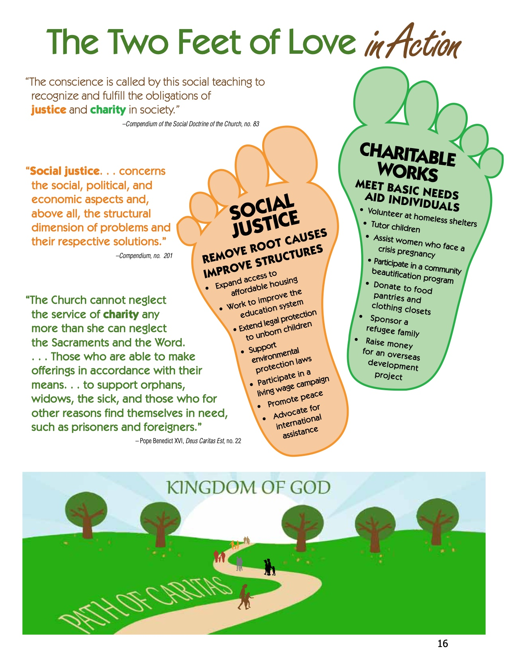

Handout #13B.

The Two Feet of Social Action Worksheet
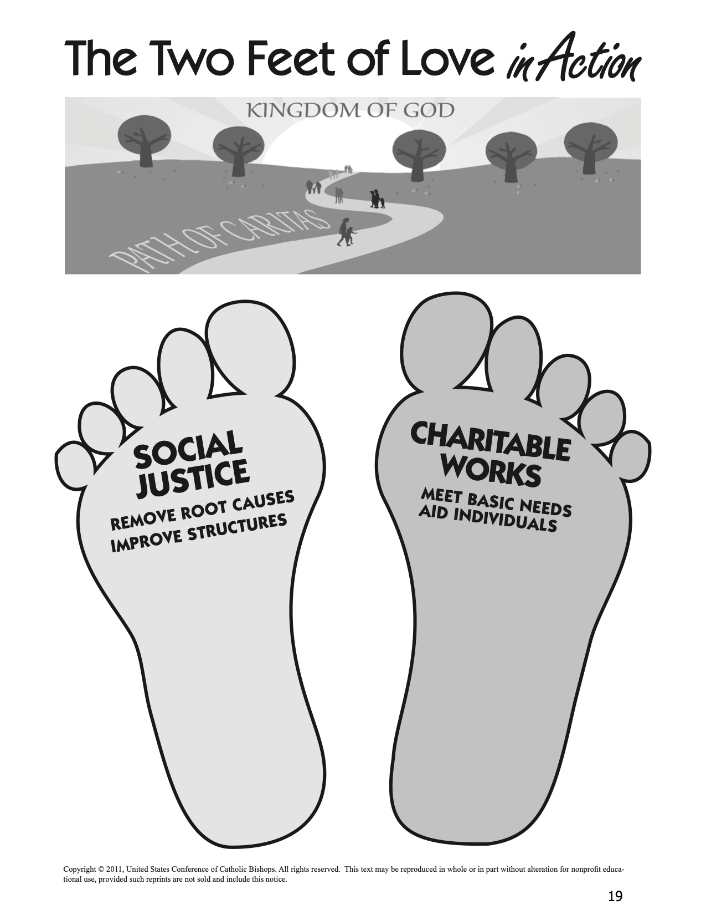

Handout #14.

Time Chart Worksheet

“For where your treasure is, there also will your heart be.”(Luke 12:34)

Sample Time Chart

School or Work:
8 hours
Sleep:
8 hours
Activities:
2 hours
Family Time:
1 hour

Entertainment:
2 hours
Other
(3 hours)

Handout #15.

Reflecting on a Justice and Service Experience

Use the following questions to develop a set of reflection questions for families and individuals to share experience and learning from a justice or service project.

Reflecting on Our Experience

- What struck you most strongly? What happened?
- What images stand out in your mind? What sights and sounds, touches and smells? What experiences and conversations? Why did they make the impression they did?
- What was happening in your heart? What did you feel? What touched you most deeply today? Why? What did you find most frustrating? Most hopeful? Why?

Reflecting on the People Served

- What did you learn about the people you met? How is their experience most like yours? How is it most different? How would you feel if you had to change places for a week? For a year? Why?
- What did you learn about yourself today? What do you like about what you learned? What do you dislike and most want to change?

Reflecting on Justice Issues Addressed

- How were justice and injustice present in the situations you faced?
- Did you learn anything new about the causes of injustice and the changes that are necessary?
- How did your action project try to address the justice issue you studied?

Reflecting on Our Faith

- How was God present in what happened within and around you? How were you “Jesus for others”? How were others “Jesus for you”?
- How did you experience the Church in action? How was the Church living its teachings through your action project?
- What did you discover about following Jesus from your involvement?

Reflecting on Our Lives

- How did your involvement start you thinking about how you are living your life as an individual and as a family? What changes might you make in your life and/or in your family’s life? What changes might you make in your priorities and/or your family’s priorities?

Closing Prayer Service

Gather

Lord God, we ask you to enlighten our minds and open our hearts to those in need of food and shelter. Forgive us for the times when we avoided our responsibility because of our fears and prejudices. Help us to have a passion for justice and to care for the weak and oppressed as you did.

Help us to develop a caring society where all people are treated with the respect and dignity they deserve. And help us today to witness actively to the Gospel as it challenges us to hear and respond to the cry of the poor.

Listen

James 2:14-17

Respond

God of justice and friend of the poor, we offer our prayers for our country and all who suffer injustice.

For the millions of our fellow citizens who are living in poverty, that despite our society’s rejection and inaction, they might feel loved and valuable in your sight.
Response: O God, hear our prayer.

For our nation, that we are moved from tolerance of poverty to passionate work for justice.
Response: O God, hear our prayer.

For the parents who struggle each day to provide food, pay the rent, keep their families together, and just survive, that they might find community supports that enable them to nurture, enjoy, and spend time with their children.
Response: O God, hear our prayer.

For the children whose needs are unmet, whose cries go unheard, and whose lives hold little joy, that we might fill their needs, respond to their pain, and seek to enrich their lives.
Response: O God, hear our prayer.

For all those who are sick and without medical insurance, that they find care and healing.
Response: O God, hear our prayer.

For our nation’s leaders, that they might make alleviating poverty the nation’s highest priority.
Response: O God, hear our prayer.

For ourselves, that we might continue, with renewed determination, to serve and advocate on behalf of the poor in our nation and world, so that every person and family have the basic necessities of life.
Response: O God, hear our prayer.

Go Forth

Lord Jesus,
Open our eyes that they may see the needs of the poor;
move our hands that they may feed the hungry;
touch our hearts that they may bring warmth to the despairing;
teach us the generosity that welcomes strangers;
let us share our possessions to clothe the naked;
give us the care that strengthens the sick;
make us share in the quest to set the prisoner free.
In serving the needs of the poor may we grow closer to you.
Amen.

