Opening Prayer Service

Gather

Share the photo meditation with background instrumental music.

Listen

The first words of the Bible make it clear to us that we are made in the image and likeness of God (Genesis 1:26-27):

Then God said, “Let us make humankind in our image, according to our likeness; and let them have dominion over the fish of the sea, and over the birds of the air, and over the cattle, and over all the wild animals of the earth, and over every creeping thing that creeps upon the earth.”
So God created humankind in his image,
in the image of God he created them;
male and female he created them.
Psalm 139 reminds each of us that we were created by God:

For it was you who formed my inward parts;
you knit me together in my mother’s womb.
I praise you, for I am fearfully and wonderfully made.
Wonderful are your works;
that I know very well.
My frame was not hidden from you,
when I was being made in secret,
intricately woven in the depths of the earth.
Your eyes beheld my unformed substance.
In your book were written
all the days that were formed for me,
when none of them as yet existed.
The Catholic Church proclaims that human life is sacred because every human person is created in the image and likeness of God. Every person is precious. Each person’s life and dignity must be respected. The human person is the clearest reflection of God’s presence in the world. All the Church’s work in pursuit of both justice and peace is designed to protect and promote the dignity of every person.

Respond

Create
In the middle of a piece of construction paper, write your name and underneath your name write: “Created in God’s Image,” “Made in God’s Image” or a similar phrase. Write large enough for people to read your name.

Add symbols, pictures, or words which describe who you are, using markers and crayons to draw or write. If you know the meaning of your first name, add this to your name tag.

Tie a piece of string or yarn on your name tag and wear it around your neck.

Discuss:
- What if everyone always wore a sign that said, “Created in God’s Image”? How would we treat each other (e.g., our family members, our friends, our co-workers, people we meet throughout the day) differently?

- How does it feel when other people treat us with respect, care, and dignity? Share an example or two.

- What if everyone in the world treated each other as if they were actually created in God’s image—with respect, care, and dignity? What would our world look like?

Closing Prayer

Father and maker of all,
you adorn all creation with splendor and beauty,
and fashion human lives in your image and likeness.
Awaken in every heart
reverence for the work of your hands,
and renew among your people
a readiness to nurture and sustain
your precious gift of life.
Grant this through our Lord Jesus Christ, your Son,
who lives and reigns with you in the unity of the Holy Spirit,
God, for ever and ever.
Amen.

Handout #2.

Our Faith Teaches . . . Dignity of Human Life

Christians believe that. . . .

- Human beings are created in the image and likeness of God (Genesis 1:22-27).
- Human life is sacred—it is a gift from God.
- The human person is central, the clearest reflection of God among us.
- Each person possesses a basic dignity that comes from God, not from any human quality or accomplishment, not from race or gender, age or economic status.
- Every human life is precious from conception through natural death.
- People are more important than things.
- The dignity of the human person is the foundation of a moral vision for society.
- The test of every institution or policy is whether it enhances or threatens human life and human dignity.

Biblical Teachings

Genesis 1:26-27
Then God said: “Let us make human beings in our image, after our likeness. Let them have dominion over the fish of the sea, the birds of the air, the tame animals, all the wild animals, and all the creatures that crawl on the earth.” God created mankind in his image; in the image of God he created them; male and female he created them.

Ex 22:20-26
“You shall not oppress or afflict a resident alien, for you were once aliens residing in the land of Egypt. You shall not wrong any widow or orphan. If ever you wrong them and they cry out to me, I will surely listen to their cry. My wrath will flare up, and I will kill you with the sword; then your own wives will be widows, and your children orphans. If you lend money to my people, the poor among you, you must not be like a money lender; you must not demand interest from them. If you take your neighbor’s cloak as a pledge, you shall return it to him before sunset; for this is his only covering; it is the cloak for his body. What will he sleep in? If he cries out to me, I will listen; for I am compassionate.”

Psalm 8:4-10
When I see your heavens, the work of your fingers, the moon and stars that you set in place—
What is man that you are mindful of him, and a son of man that you care for him?
Yet you have made him little less than a god, crowned him with glory and honor.
You have given him rule over the works of your hands, put all things at his feet:
All sheep and oxen, even the beasts of the field,
The birds of the air, the fish of the sea, and whatever swims the paths of the seas.
O Lord, our Lord, how awesome is your name through all the earth!

Jeremiah 1:5
“Before I formed you in the womb I knew you, before you were born I dedicated you…”

Matthew 5:21-22
“You have heard that it was said to the men of old, ‘You shall not kill; and whoever kills shall be liable to judgment’. But I say to you that everyone who is angry with his brother shall be liable to judgment.”

Matthew 19:13-14
Then children were brought to him that he might lay his hands on them and pray. The disciples rebuked them, but Jesus said, “Let the children come to me, and do not prevent them; for the kingdom of heaven belongs to such as these.”

Luke 10:25-37
There was a scholar of the law who stood up to test him and said, “Teacher, what must I do to inherit eternal life?” Jesus said to him, “What is written in the law? How do you read it?”

He said in reply, “You shall love the Lord, your God, with all your heart, with all your being, with all your strength, and with all your mind, and your neighbor as yourself.”

He replied to him, “You have answered correctly; do this and you will live.”

But because he wished to justify himself, he said to Jesus, “And who is my neighbor?” Jesus replied, “A man fell victim to robbers as he went down from Jerusalem to Jericho. They stripped and beat him and went off leaving him half-dead. A priest happened to be going down that road, but when he saw him, he passed by on the opposite side. Likewise a Levite came to the place, and when he saw him, he passed by on the opposite side. But a Samaritan traveler who came upon him was moved with compassion at the sight.

He approached the victim, poured oil and wine over his wounds and bandaged them. Then he lifted him up on his own animal, took him to an inn and cared for him. The next day he took out two silver coins and gave them to the innkeeper with the instruction, ‘Take care of him. If you spend more than what I have given you, I shall repay you on my way back.

“Which of these three, in your opinion, was neighbor to the robbers’ victim?” He answered, “The one who treated him with mercy.” Jesus said to him, “Go and do likewise.”

Luke 12:26-28
If even the smallest things are beyond your control, why are you anxious about the rest? Notice how the flowers grow. They do not toil or spin. But I tell you, not even Solomon in all his splendor was dressed like one of them. If God so clothes the grass in the field that grows today and is thrown into the oven tomorrow, will he not much more provide for you, O you of little faith?

John 10:10
“I came so that they might have life and have it more abundantly.”

John 15:15-17
“I no longer call you slaves, because a slave does not know what his master is doing. I have called you friends, because I have told you everything I have heard from my Father. It was not you who chose me, but I who chose you and appointed you to go and bear fruit that will remain, so that whatever you ask the Father in my name he may give you. This I command you: love one another.”

Romans 5:6-8
For Christ, while we were still helpless, yet died at the appointed time for the ungodly. Indeed, only with difficulty does one die for a just person, though perhaps for a good person one might even find courage to die. But God proves his love for us in that while we were still sinners Christ died for us.

Romans 12:16
Contribute to the needs of the holy ones, exercise hospitality. Bless those who persecute [you], bless and do not curse them. Rejoice with those who rejoice, weep with those who weep. Have the same regard for one another; do not be haughty but associate with the lowly; do not be wise in your own estimation.

Romans 13:9-10
“The commandments, ‘You shall not commit adultery, You shall not kill, You shall not steal, You shall not covet’, and any other commandment, are summed up in this sentence, ‘You shall love your neighbor as yourself’. Love does no wrong to a neighbor; therefore love is the fulfilling of the law.”

1 Corinthians 12:12-26
As a body is one though it has many parts, and all the parts of the body, though many, are one body, so also Christ. For in one Spirit we were all baptized into one body, whether Jews or Greeks, slaves or free persons, and we were all given to drink of one Spirit. Now the body is not a single part, but many. If a foot should say, “Because I am not a hand I do not belong to the body,” it does not for this reason belong any less to the body. Or if an ear should say, “Because I am not an eye I do not belong to the body,” it does not for this reason belong any less to the body. If the whole body were an eye, where would the hearing be? If the whole body were hearing, where would the sense of smell be?

But as it is, God placed the parts, each one of them, in the body as he intended. If they were all one part, where would the body be? But as it is, there are many parts, yet one body. The eye cannot say to the hand, “I do not need you,” nor again the head to the feet, “I do not need you.” Indeed, the parts of the body that seem to be weaker are all the more necessary, and those parts of the body that we consider less honorable we surround with greater honor, and our less presentable parts are treated with greater propriety, whereas our more presentable parts do not need this. But God has so constructed the body as to give greater honor to a part that is without it, so that there may be no division in the body, but that the parts may have the same concern for one another. If [one] part suffers, all the parts suffer with it; if one part is honored, all the parts share its joy.

Ephesians 2:8-10
For by grace you have been saved through faith, and this is not from you; it is the gift of God; it is not from works, so no one may boast. For we are his handiwork, created in Christ Jesus for the good works that God has prepared in advance, that we should live in them.

Ephesians 5:1-2
So be imitators of God, as beloved children, and live in love, as Christ loved us and handed himself over for us as a sacrificial offering to God.

1 John 3:1
See what love the Father has bestowed on us that we may be called the children of God. Yet so we are.

Handout #3.

Beliefs that Lead to Action

We believe that every person is precious, that people are more important than things, and that the measure of every institution is whether it threatens or enhances the life and dignity of the human person.

As people of faith and followers of Jesus Christ, we believe…

1.

2.

3.

4.

Yet in our nation and world we see the situation...

1.

2.

3.

4.

Things have to change!

People need to be more aware of how the human dignity of people is being abused and denied. This can be done by . . .

People need to reach out to assist people whose human dignity is being oppressed or forgotten or abused. This can be done by . . .

People need to advocate for public policies that support and enhance human dignity. This can be done by . . .

Handout #4.

The Two Feet of Social Action

The Work of Service

- Focuses on the needs of individuals and families
- Looks at individual situations of need
- Meets an immediate need
- Addresses painful individual symptoms of social problems

The Work of Justice

- Focuses on the rights of individuals, families, and all creation
- Analyzes social situations or social structures
- Works for long-term social change
- Addresses the underlying social causes of individual problems
- Relies on just laws and fair social structures

One foot: Works of Service—Responding to people in need

- preparing and serving a meal at a soup kitchen or homeless shelter
- collecting food for the local food bank
- donating clothes to those in need
- creating “essentials kits” for those in need
- visiting the elderly and homebound
- tutoring children
- visiting the sick

Second foot: Works of Justice—Addressing the root causes of social problems

- letter writing on important social issues and legislation
- working with groups to change legislation or budget priorities
- supporting organizations working for justice with time and money
- providing financial support to organizations that work globally to overcome injustice
- developing a program or campaign to educate people in your community about poverty
- developing a program or campaign to educate people in your community about human dignity and the threats to human dignity

Works of Service

Handout #5.

The Two Feet of Social Action Worksheet
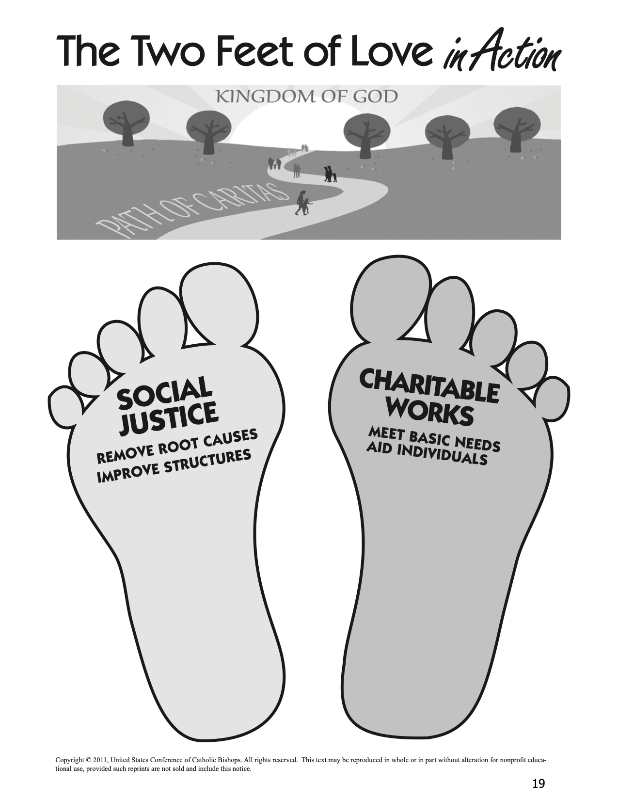

Handout #6.

Reflecting on a Justice and Service Experience

Use the following questions to develop a set of reflection questions for families and individuals to share experience and learning from a justice or service project that focuses on caring for God’s creation.

Reflecting on Our Experience

- What struck you most strongly? What happened?
- What images stand out in your mind? What sights and sounds, touches and smells? What experiences and conversations? Why did they make the impression they did?
- What was happening in your heart? What did you feel? What touched you most deeply today? Why? What did you find most frustrating? Most hopeful? Why?

Reflecting on the People Served

- What did you learn about the people you met? How is their experience most like yours? How is it most different? How would you feel if you had to change places for a week? a year? Why?
- What did you learn about yourself today? What do you like about what you learned? What do you dislike and most want to change?

Reflecting on Justice Issues Addressed

- How were justice and injustice present in the situations you faced?
- Did you learn anything new about the causes of injustice and the changes that are necessary?
- How did your action project try to address the justice issue you studied?

Reflecting on Our Faith

- How was God present in what happened within and around you? How did you expressed respect for God’s creation?
- How did you experience the Church in action? How was the Church living its teachings through your action project?

Reflecting on Our Lives

- How did your involvement start you thinking about how you are living your life as an individual and as a family?
- What changes might you make in your life and/or in your family’s life? What changes might you make in your priorities and/or your family’s priorities,

Handout #7.

Background Reading for Presenter
(Albert Nolan, Jesus Before Christianity, Maryknoll, NY: Orbis Books, 2001)

Jesus upheld the dignity and worth of children (see Matthew 18:1-4). “The child is a live parable of ‘littleness,’ the opposite of greatness, status and prestige. Children in that society had no status at all—they did not count. But for Jesus they are also people and they do count. That is why he is indignant when his disciples chase the children away. He would call them to him, put his arms around them and bless them by laying his hands on their heads. ‘For,’ he says, ‘it is to such as these that the kingdom of God belongs’ (Mark 10:14). It will be a ‘kingdom’ of ‘children’ or rather of those who are like children because in society they are insignificant; they lack status and prestige.”

“But the little child who is an image of the ‘kingdom’ is a symbol of those who have the lowest places in society, the poor and the oppressed, the beggars, the prostitutes and tax collectors—the people whom Jesus often called the little ones or the least.”

“Jesus’ love for the poor and oppressed was not an exclusive love; it was an indication of the fact that what he valued was humanity not status and prestige. The poor and the oppressed had nothing to recommend them except their humanity and sufferings. Jesus was also concerned about the middle and upper classes—not because they were especially important people but because they too were people. He wanted them to strip themselves of false values, of their wealth and prestige, in order to become real people. Jesus wished to replace the ‘worldly’ value of prestige by the ‘godly’ value of people as people.”

“A further indication of the way in which Jesus valued people as people would be his attitude to women. In the society of his time ‘to be born female was a disadvantage, the sign, perhaps, that an expectant mother’s or father’s prayers were not answered.’ Women, like children, did not count. They could not become disciples of a scribe or members of the Sadducee, Pharisee, Essene or Zealot ‘parties.’ The woman’s role was sex and motherhood.

“Jesus stood out among his contemporaries (and most of his subsequent followers) as someone who gave women exactly the same value and dignity as men. He showed the same concern for the widow of Nain, Simon’s mother-in-law, the women with hemorrhage and the Canaanite woman as he showed for anyone else in need. He could count women among his friends and his followers (Mark 15:40-41; Luke 7:36-50; 8:2-3; John 11:5; 20:11-18). . . Jesus had no scruples about mixing with prostitutes (Luke 7:36-50 and compare Matthew 11:19 with 21:31, 32) or with unchaperoned women (John 4:7-27; 8:10-11). People were people and that was what mattered.”

“The ‘kingdom’ of God, then, will be a society in which there will be no prestige and no status, no division of people into inferior and superior. Everyone will be loved and respected, not because of one’s education or wealth or ancestry or authority or rank or other achievements, but because one like everybody else is a person. Some will find it very difficult to image why such a life would be like but the “babes” who have never had any of the privileges of status and those who have not valued it will find it very easy to appreciate the fulfillment that life in such a society would bring. These who could not bear to have beggars, formers prostitutes, servants, women and children treated as their equals, who could not live without feeling superior to at least some people, who simply not be at home in God’s ‘kingdom’ as Jesus understood it. They would want to exclude themselves from it.”

Closing Prayer Service

Gather

God of Life, you proclaim that all human life is sacred and that every person is precious in your sight. Give us the courage to work toward a world that respects and protects the human dignity of all people regardless of what society tells us to think. Help us to create a world where every human life counts from conception to old age. Amen.

Listen

- Deuteronomy 30:15-20 (Choose Life)
- One of the Gospel stories used in the session. See chart on p. x

Respond

For children who are unwanted, unloved, neglected, or abused, that God may fill their voids with his love, we pray:
Response: Lord, hear our prayer for dignity of all people.

For all who do not embrace the rights of the unborn that, in love, they may come to know and treasure the infinite value of every human person, we pray:
Response: Lord, hear our prayer for dignity of all people.

For parents who struggle to make ends meet, that they may find strength when they grow weary, and that they may earn a just wage, we pray:
Response: Lord, hear our prayer for dignity of all people.

For families and persons who care for those with special emotional or physical needs, we pray:
Response: Lord, hear our prayer for dignity of all people.

For those who have grown old, that society will acknowledge the contributions which the elderly have made and continue to make to our world, we pray:
Response: Lord, hear our prayer for dignity of all people.

For those coming through the bleakness of drug or alcohol addiction, unsure of their ability to face life without these supports, we pray:
Response: Lord, hear our prayer for dignity of all people.

For the unemployed, that they may not lose courage and hope while searching for work, we pray:
Response: Lord, hear our prayer for dignity of all people.

For the hungry, may they have enough, we pray:
Response: Lord, hear our prayer for dignity of all people.

For those deprived of their human needs and their human rights, that they may be given the dignity you confer on all your people, we pray:
Response: Lord, hear our prayer for dignity of all people.

For those who witness to the rights of all human beings. that God might strengthen and guide them, we pray:
Response: Lord, hear our prayer for dignity of all people.

For a spirit of repentance and conversion, that the culture of death may be defeated by the power of the Cross of Jesus, we pray:
Response: Lord, hear our prayer for dignity of all people.

For all who are about to die, that through our love, care, and devotion, they might know the beauty of life, to the moment of their final breath, we pray:
Response: Lord, hear our prayer for dignity of all people.

For those who long for the equality of all persons, that their dedication to the unborn, the old, the condemned, and the forgotten may grow every day, we pray:
Response: Lord, hear our prayer for dignity of all people.

For all who teach the Gospel of Life, that they might be driven by love alone, we pray:
Response: Lord, hear our prayer for dignity of all people.

For those who work to change our laws to reflect the Gospel of Life, that God might inspire and shepherd them, we pray:
Response: Lord, hear our prayer for dignity of all people.

Go Forth

Father and maker of all,
you adorn all creation
with splendor and beauty,
and fashion human lives
in your image and likeness.
Awaken in every heart
reverence for the work of your hands,
and renew among your people
a readiness to nurture and sustain
your precious gift of life.
Grant this through our Lord Jesus Christ, your Son,
who lives and reigns with you in the unity of the Holy Spirit,
God, for ever and ever.
Amen.

