Opening Prayer Service

Gather

Share the photo meditation with background instrumental music.

Listen

The first words of the Bible make it clear to us that we are made in the image and likeness of God (Genesis 1:26-27):

Then God said, “Let us make humankind in our image, according to our likeness; and let them have dominion over the fish of the sea, and over the birds of the air, and over the cattle, and over all the wild animals of the earth, and over every creeping thing that creeps upon the earth.”
So God created humankind in his image,
in the image of God he created them;
male and female he created them.
Psalm 139 reminds each of us that we were created by God:

For it was you who formed my inward parts;
you knit me together in my mother’s womb.
I praise you, for I am fearfully and wonderfully made.
Wonderful are your works;
that I know very well.
My frame was not hidden from you,
when I was being made in secret,
intricately woven in the depths of the earth.
Your eyes beheld my unformed substance.
In your book were written
all the days that were formed for me,
when none of them as yet existed.
The Catholic Church proclaims that human life is sacred because every human person is created in the image and likeness of God. Every person is precious. Each person’s life and dignity must be respected. The human person is the clearest reflection of God’s presence in the world. All the Church’s work in pursuit of both justice and peace is designed to protect and promote the dignity of every person.

Respond

Create
In the middle of a piece of construction paper, write your name and underneath your name write: “Created in God’s Image,” “Made in God’s Image” or a similar phrase. Write large enough for people to read your name.

Add symbols, pictures, or words which describe who you are, using markers and crayons to draw or write. If you know the meaning of your first name, add this to your name tag.

Tie a piece of string or yarn on your name tag and wear it around your neck.

Discuss:
- What if everyone always wore a sign that said, “Created in God’s Image”? How would we treat each other (e.g., our family members, our friends, our co-workers, people we meet throughout the day) differently?

- How does it feel when other people treat us with respect, care, and dignity? Share an example or two.

- What if everyone in the world treated each other as if they were actually created in God’s image—with respect, care, and dignity? What would our world look like?

Closing Prayer

Father and maker of all,
you adorn all creation with splendor and beauty,
and fashion human lives in your image and likeness.
Awaken in every heart
reverence for the work of your hands,
and renew among your people
a readiness to nurture and sustain
your precious gift of life.
Grant this through our Lord Jesus Christ, your Son,
who lives and reigns with you in the unity of the Holy Spirit,
God, for ever and ever.
Amen.

Handout #2.

The Church Teaches . . . Dignity of Human Life

The Catholic Church teaches that. . .

- Human beings are created in the image and likeness of God (Genesis 1:22-27).
- Human life is sacred—it is a gift from God.
- The human person is central, the clearest reflection of God among us.
- Each person possesses a basic dignity that comes from God, not from any human quality or accomplishment, not from race or gender, age or economic status.
- Every human life is precious from conception through natural death.
- People are more important than things.
- The dignity of the human person is the foundation of a moral vision for society.
- The test of every institution or policy is whether it enhances or threatens human life and human dignity.

Church Teachings

1
“Every human person is created in the image and likeness of God. Therefore, each person’s life and dignity must be respected, whether that person is an innocent unborn child in a mother’s womb, whether that person worked in the World Trade Center or a market in Baghdad, or even whether that person is a convicted criminal on death row. We believe that every human life is sacred from conception to natural death, that people are more important than things, and that the measure of every institution is whether it protects and respects the life and dignity of the human person. As the recent Vatican statement points out, ‘The Church recognizes that while democracy is the best expression of the direct participation of citizens in political choices, it succeeds only to the extent that it is based on a correct understanding of the human person. Catholic involvement in political life cannot compromise on this principle.’” (United States Conference of Catholic Bishops, Faithful Citizenship, 13)

2
“In a world warped by materialism and declining respect for human life, the Catholic Church proclaims that human life is sacred and that the dignity of the human person is the foundation of a moral vision for society. Our belief in the sanctity of human life and the inherent dignity of the human person is the foundation of all the principles of our social teaching. In our society, human life is under direct attack from abortion and assisted suicide. The value of human life is being threatened by increasing use of the death penalty. The dignity of life is undermined when the creation of human life is reduced to the manufacture of a product, as in human cloning or proposals for genetic engineering to create ‘perfect’ human beings. We believe that every person is precious, that people are more important than things, and that the measure of every institution is whether it threatens or enhances the life and dignity of the human person.” (United States Conference of Catholic Bishops, Sharing Catholic Social Teaching, 4)

3
Thus the deepest element of God’s commandment to protect human life is the requirement to show reverence and love for every person and the life of every person. This is the teaching which the Apostle Paul, echoing the words of Jesus, addresses to the Christians in Rome: “The commandments, ‘You shall not commit adultery, You shall not kill, You shall not steal, You shall not covet’, and any other commandment, are summed up in this sentence, ‘You shall love your neighbor as yourself’. Love does no wrong to a neighbor; therefore love is the fulfilling of the law” (Rom 13:9-10).

4
“At the center of all Catholic social teaching are the transcendence of God and the dignity of the human person. The human person is the clearest reflection of God’s presence in the world; all of the Church’s work in pursuit of both justice and peace is designed to protect and promote the dignity of every person. For each person not only reflect God, but is the expression of God’s creative work and the meaning of Christ’s redemptive ministry.” (United States Conference of Catholic Bishops, The Challenge of Peace, #15)

“The center of the Church’s social teaching is the life, dignity, and rights of the human person. We are called in a special way to serve the poor and vulnerable; to build bridges of solidarity among peoples of differing races and nations, language and ability, gender and culture.” (United States Conference of Catholic Bishops, Communities of Salt and Light, 3)

“At the summit of creation stands the creation of man and woman, made in God’s image (Genesis 1:26-27). As such every human being possesses an inalienable dignity that stamps human existence prior to any division into races or nations and prior to human labor and human achievement.” (United States Conference of Catholic Bishops, Economic Justice for All, 15)

5
“We live the Gospel of Life when we live in solidarity with the poor of the world, standing up for their lives and dignity. Yet abortion and euthanasia have become preeminent threats to human dignity because they directly attack life itself, the most fundamental human good and the condition for all others. They are committed against those who are weakest and most defenseless, those who are genuinely ‘the poorest of the poor.’” (United States Conference of Catholic Bishops, Living the Gospel of Life: A Challenge to American Catholics, #5)

“The basis for all that the Church believes about the moral dimensions of economic life is its vision of the transcendent worth—the sacredness—of human beings. The dignity of the human person, realized in community with others, is the criterion against which all aspects of economic life must be measured.”
(United States Conference of Catholic Bishops, Economic Justice for All, 14)

6
“Human life is a gift from God, sacred and inviolable. Because every human person is created in the image and likeness of God, we have a duty to defend human life from conception until natural death and in every condition.

“Our world does not lack for threats to human life. We watch with horror the deadly violence of terror, war, starvation, and children dying from disease. We face a new and insidious mentality that denies the dignity of some vulnerable human lives and treats killing as a personal choice and social good. As we wrote in Living the Gospel of Life, ‘Abortion and euthanasia have become preeminent threats to human life and dignity because they directly attack life itself, the most fundamental good and the condition for all others.’ Abortion, the deliberate killing of a human being before birth, is never morally acceptable. The destruction of human embryos as objects of research is wrong. This wrong is compounded when human life is created by cloning or other means only to be destroyed. The purposeful taking of human life by assisted suicide and euthanasia is never an act of mercy. It is an unjustifiable assault on human life. For the same reasons, the intentional targeting of civilians in war or terrorist attacks is always wrong.

“In protecting human life, ‘We must begin with a commitment never to intentionally kill, or collude in the killing, of any innocent human life, no matter how broken, unformed, disabled or desperate that life may seem.’” (United States Conference of Catholic Bishops, Faithful Citizenship)

7
We urge Catholics and others to promote laws and social policies that protect human life and promote human dignity to the maximum degree possible. Laws that legitimize abortion, assisted suicide, and euthanasia are profoundly unjust and immoral. We support constitutional protection for unborn human life, as well as legislative efforts to end abortion and euthanasia. We encourage the passage of laws and programs that promote childbirth and adoption over abortion and assist pregnant women and children. We support aid to those who are sick and dying by encouraging health care coverage for all as well as effective palliative care. We call on government and medical researchers to base their decisions regarding biotechnology and human experimentation on respect for the inherent dignity and inviolability of human life from its very beginning, regardless of the circumstances of its origin.
(United States Conference of Catholic Bishops, Faithful Citizenship)

8
Catholic teaching calls on us to work to avoid war. Nations must protect the right to life by finding ever more effective ways to prevent conflicts from arising, to resolve them by peaceful means, and to promote post-conflict reconstruction and reconciliation. All nations have a right and duty to defend human life and the common good against terrorism, aggression, and similar threats. In the aftermath of September 11, we called for continuing outreach to those who had been harmed, clear resolve in responding to terror, moral restraint in the means used, respect for ethical limits on the use of force, greater focus on the roots of terror, and a serious effort to share fairly the burdens of this response. While military force as a last resort can sometimes be justified to defend against aggression and similar threats to the common good, we have raised serious moral concerns and questions about preemptive or preventive use of force. (United States Conference of Catholic Bishops, Faithful Citizenship)

9
Even when military force is justified, it must be discriminate and proportionate. Direct, intentional attacks on civilians in war are never morally acceptable. Nor is the use of weapons of mass destruction or other weapons that cause disproportionate harm or that cannot be deployed in ways that distinguish between civilians and soldiers. Therefore, we urge our nation to strengthen barriers against the use of nuclear weapons, to expand controls over existing nuclear materials and other weapons of mass destruction, and to ratify the Comprehensive Test Ban Treaty as a step toward much deeper cuts and the eventual elimination of nuclear weapons. We also urge our nation to join the treaty to ban anti-personnel landmines and to address the human consequences of cluster bombs. We further urge our nation to take immediate and serious steps to reduce its own disproportionate role in the scandalous global trade in arms, which contributes to violent conflicts around the world. (United States Conference of Catholic Bishops, Faithful Citizenship)

10
Society has a right and duty to defend itself against violent crime and a duty to reach out to victims of crime. Yet our nation’s increasing reliance on the death penalty cannot be justified. We do not teach that killing is wrong by killing those who kill others. Pope John Paul II has said the penalty of death is “both cruel and unnecessary”. The antidote to violence is not more violence. In light of the Holy Father’s insistence that this is part of our pro-life commitment, we encourage solutions to violent crime that reflect the dignity of the human person, urging our nation to abandon the use of capital punishment. We also urge passage of legislation that would address problems in the judicial system, and restrict and restrain the use of the death penalty through use of DNA evidence, a guarantee of effective counsel, and efforts to address issues of racial justice. (United States Conference of Catholic Bishops, Faithful Citizenship)

11
Social friendship and universal fraternity necessarily call for an acknowledgement of the worth of every human person, always and everywhere. If each individual is of such great worth, it must be stated clearly and firmly that “the mere fact that some people are born in places with fewer resources or less development does not justify the fact that they are living with less dignity”. This is a basic principle of social life that tends to be ignored in a variety of ways by those who sense that it does not fit into their worldview or serve their purposes. (#106)

Every human being has the right to live with dignity and to develop integrally; this fundamental right cannot be denied by any country. People have this right even if they are unproductive, or were born with or developed limitations. This does not detract from their great dignity as human persons, a dignity based not on circumstances but on the intrinsic worth of their being. Unless this basic principle is upheld, there will be no future either for fraternity or for the survival of humanity. (#107)
(Pope Francis, Fratelli Tutti)

Handout #3.

Reflections: The Gospel of Life, Pope John Paul II

41. The commandment “You shall not kill”, included and more fully expressed in the positive command of love for one’s neighbor, is reaffirmed in all its force by the Lord Jesus. To the rich young man who asks him: “Teacher, what good deed must I do, to have eternal life?”, Jesus replies: “If you would enter life, keep the commandments” (Matthew 19:16,17). And he quotes, as the first of these: “You shall not kill” (Matthew 19:18). In the Sermon on the Mount, Jesus demands from his disciples a righteousness which surpasses that of the Scribes and Pharisees, also with regard to respect for life: “You have heard that it was said to the men of old, ?You shall not kill; and whoever kills shall be liable to judgment’. But I say to you that everyone who is angry with his brother shall be liable to judgment” (Matthew 5:21-22).

By his words and actions Jesus further unveils the positive requirements of the commandment regarding the inviolability of life. These requirements were already present in the Old Testament, where legislation dealt with protecting and defending life when it was weak and threatened: in the case of foreigners, widows, orphans, the sick and the poor in general, including children in the womb (cf. Ex 21:22; 22:20-26). With Jesus these positive requirements assume new force and urgency, and are revealed in all their breadth and depth: they range from caring for the life of one’s brother (whether a blood brother, someone belonging to the same people, or a foreigner living in the land of Israel) to showing concern for the stranger, even to the point of loving one’s enemy.

A stranger is no longer a stranger for the person who must become a neighbor to someone in need, to the point of accepting responsibility for his life, as the parable of the Good Samaritan shows so clearly (cf. Luke 10:25-37). Even an enemy ceases to be an enemy for the person who is obliged to love him (cf. Matthew 5:38-48; Luke 6:27-35), to “do good” to him (cf. Luke 6:27, 33, 35) and to respond to his immediate needs promptly and with no expectation of repayment (cf. Luke 6:34-35). The height of this love is to pray for one’s enemy. By so doing we achieve harmony with the providential love of God: “But I say to you, love your enemies and pray for those who persecute you, so that you may be children of your Father who is in heaven; for he makes his sun rise on the evil and on the good and sends rain on the just and on the unjust” (Matthew 5:44-45; cf. Luke 6:28, 35).

Thus the deepest element of God’s commandment to protect human life is the requirement to show reverence and love for every person and the life of every person. This is the teaching which the Apostle Paul, echoing the words of Jesus, addresses to the Christians in Rome: “The commandments, ‘You shall not commit adultery, You shall not kill, You shall not steal, You shall not covet’, and any other commandment, are summed up in this sentence, ‘You shall love your neighbor as yourself’. Love does no wrong to a neighbor; therefore love is the fulfilling of the law” (Rom 13:9-10).

79. We are the people of life because God, in his unconditional love, has given us the Gospel of life and by this same Gospel we have been transformed and saved. We have been ransomed by the “Author of life” (Acts 3:15) at the price of his precious blood (cf. 1 Corinthians 6:20; 7:23; 1 Pet 1:19). Through the waters of Baptism we have been made a part of him (cf. Rom 6:4-5; Col 2:12), as branches which draw nourishment and fruitfulness from the one tree (cf. John 15:5). Interiorly renewed by the grace of the Spirit, “who is the Lord and giver of life”, we have become a people for life and we are called to act accordingly.

We have been sent. For us, being at the service of life is not a boast but rather a duty, born of our awareness of being “God’s own people, that we may declare the wonderful deeds of him who called us out of darkness into his marvelous light” (cf. 1 Pet 2:9). On our journey we are guided and sustained by the law of love: a love which has as its source and model the Son of God made man, who “by dying gave life to the world”.

We have been sent as a people. Everyone has an obligation to be at the service of life. This is a properly “ecclesial” responsibility, which requires concerted and generous action by all the members and by all sectors of the Christian community. This community commitment does not however eliminate or lessen the responsibility of each individual, called by the Lord to “become the neighbor” of everyone: “Go and do likewise” (Luke 10:37).

Together we all sense our duty to preach the Gospel of life, to celebrate it in the Liturgy and in our whole existence, and to serve it with the various programs and structures which support and promote life.

81. This involves above all proclaiming the core of this Gospel. It is the proclamation of a living God who is close to us, who calls us to profound communion with himself and awakens in us the certain hope of eternal life. It is the affirmation of the inseparable connection between the person, his life and his bodiliness. It is the presentation of human life as a life of relationship, a gift of God, the fruit and sign of his love. It is the proclamation that Jesus has a unique relationship with every person, which enables us to see in every human face the face of Christ. It is the call for a “sincere gift of self” as the fullest way to realize our personal freedom.

It also involves making clear all the consequences of this Gospel. These can be summed up as follows: human life, as a gift of God, is sacred and inviolable. For this reason procured abortion and euthanasia are absolutely unacceptable. Not only must human life not be taken, but it must be protected with loving concern. The meaning of life is found in giving and receiving love, and in this light human sexuality and procreation reach their true and full significance. Love also gives meaning to suffering and death; despite the mystery which surrounds them, they can become saving events. Respect for life requires that science and technology should always be at the service of man and his integral development. Society as a whole must respect, defend and promote the dignity of every human person, at every moment and in every condition of that person’s life.

Handout #4.

Beliefs that Lead to Action

“We believe that every person is precious, that people are more important than things, and that the measure of every institution is whether it threatens or enhances the life and dignity of the human person.” (United States Conference of Catholic Bishops, Sharing Catholic Social Teaching, 4)

As people of faith and followers of Jesus Christ, we believe…

1.

2.

3.

4.

Yet in our nation and world we see the situation...

1.

2.

3.

4.

Things have to change!

People need to be more aware of how the human dignity of people is being abused and denied. This can be done by . . .

People need to reach out to assist people whose human dignity is being oppressed or forgotten or abused. This can be done by . . .

People need to advocate for public policies that support and enhance human dignity. This can be done by . . .

Handout #5.

The Two Feet of Social Action

The Work of Service

- Focuses on the needs of individuals and families
- Looks at individual situations of need
- Meets an immediate need
- Addresses painful individual symptoms of social problems

The Work of Justice

- Focuses on the rights of individuals, families, and all creation
- Analyzes social situations or social structures
- Works for long-term social change
- Addresses the underlying social causes of individual problems
- Relies on just laws and fair social structures

One foot: Works of Service—Responding to people in need

- preparing and serving a meal at a soup kitchen or homeless shelter
- collecting food for the local food bank
- donating clothes to those in need
- creating “essentials kits” for those in need
- visiting the elderly and homebound
- tutoring children
- visiting the sick

Second foot: Works of Justice—Addressing the root causes of social problems

- letter writing on important social issues and legislation
- working with groups to change legislation or budget priorities
- supporting organizations working for justice with time and money
- providing financial support to organizations that work globally to overcome injustice
- developing a program or campaign to educate people in your community about poverty
- developing a program or campaign to educate people in your community about human dignity and the threats to human dignity

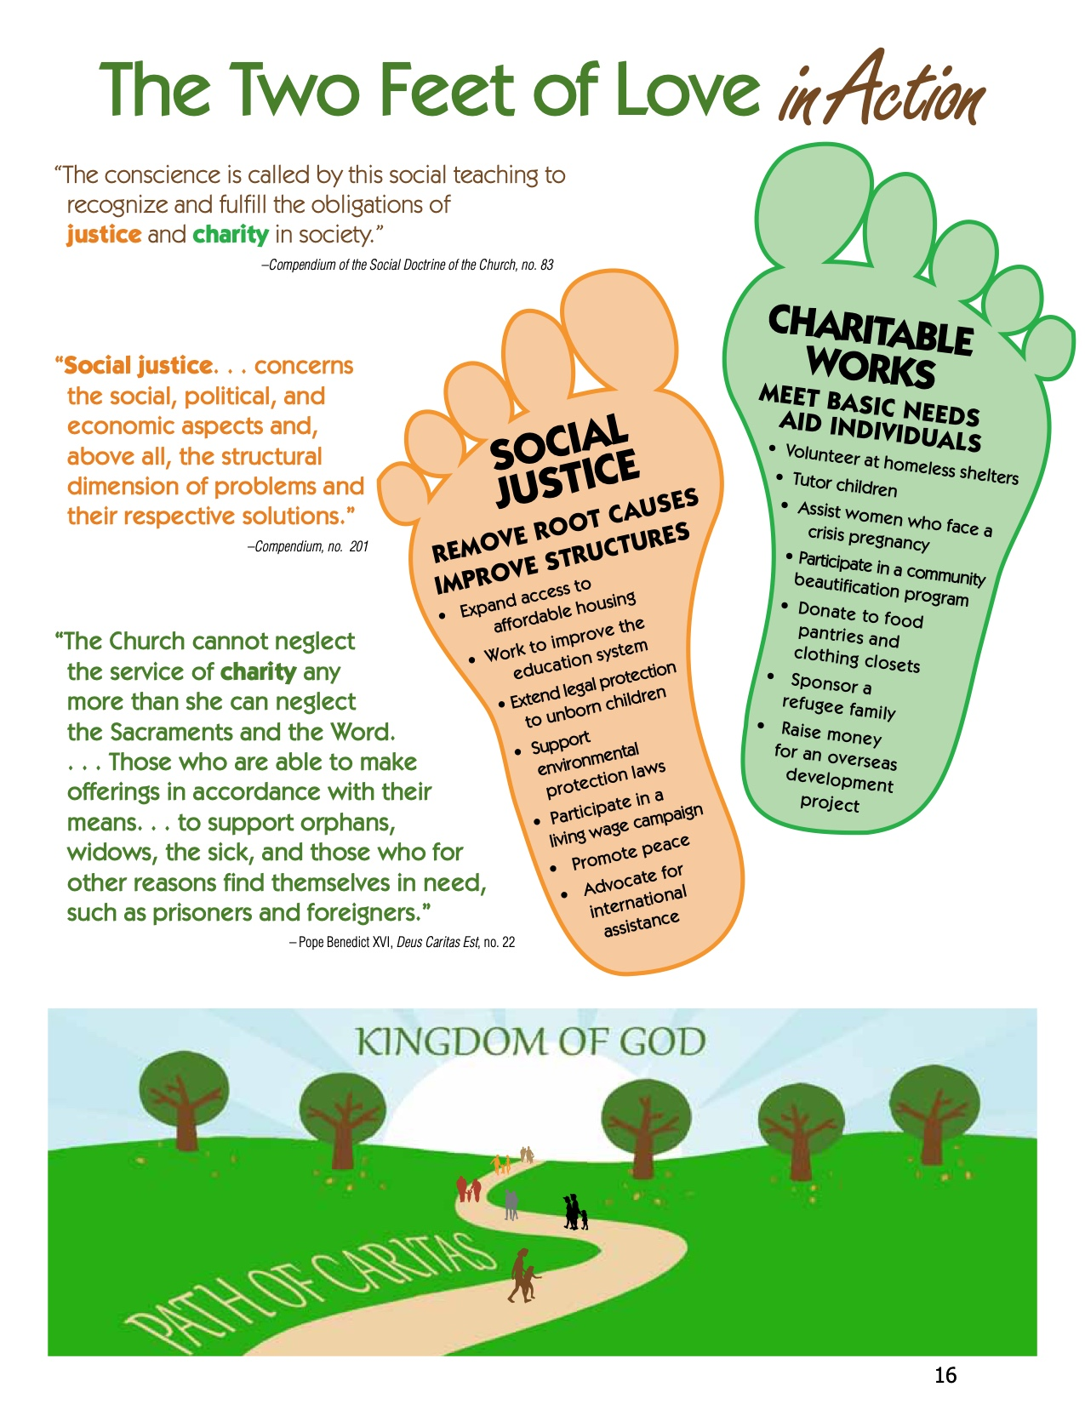

Handout #6.

The Two Feet of Social Action Worksheet
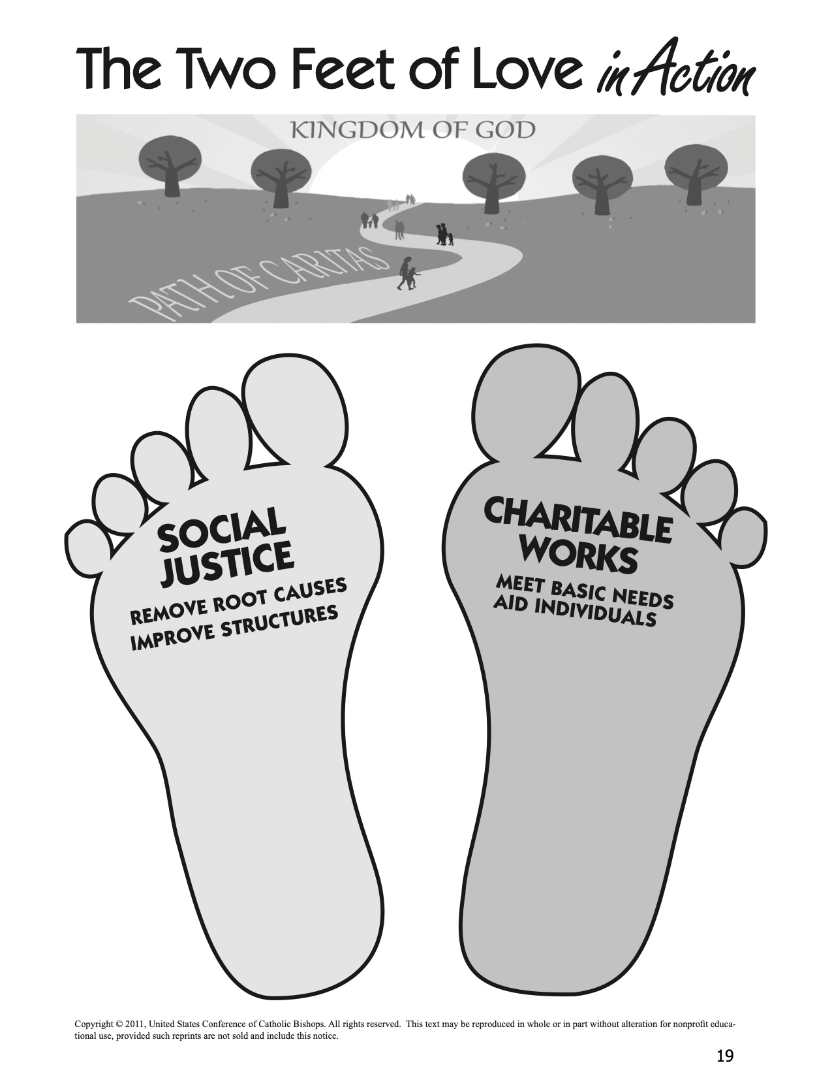

Handout #7.

Reflecting on a Justice and Service Experience

Use the following questions to develop a set of reflection questions for families and individuals to share experience and learning from a justice or service project that focuses on caring for God’s creation.

Reflecting on Our Experience

- What struck you most strongly? What happened?
- What images stand out in your mind? What sights and sounds, touches and smells? What experiences and conversations? Why did they make the impression they did?
- What was happening in your heart? What did you feel? What touched you most deeply today? Why? What did you find most frustrating? Most hopeful? Why?

Reflecting on the People Served

- What did you learn about the people you met? How is their experience most like yours? How is it most different? How would you feel if you had to change places for a week? a year? Why?
- What did you learn about yourself today? What do you like about what you learned? What do you dislike and most want to change?

Reflecting on Justice Issues Addressed

- How were justice and injustice present in the situations you faced?
- Did you learn anything new about the causes of injustice and the changes that are necessary?
- How did your action project try to address the justice issue you studied?

Reflecting on Our Faith

- How was God present in what happened within and around you? How did you expressed respect for God’s creation?
- How did you experience the Church in action? How was the Church living its teachings through your action project?

Reflecting on Our Lives

- How did your involvement start you thinking about how you are living your life as an individual and as a family?
- What changes might you make in your life and/or in your family’s life? What changes might you make in your priorities and/or your family’s priorities,

Handout #8.

Background Reading for Presenter
(Albert Nolan, Jesus Before Christianity, Maryknoll, NY: Orbis Books, 2001)

Jesus upheld the dignity and worth of children (see Matthew 18:1-4). “The child is a live parable of ‘littleness,’ the opposite of greatness, status and prestige. Children in that society had no status at all—they did not count. But for Jesus they are also people and they do count. That is why he is indignant when his disciples chase the children away. He would call them to him, put his arms around them and bless them by laying his hands on their heads. ‘For,’ he says, ‘it is to such as these that the kingdom of God belongs’ (Mark 10:14). It will be a ‘kingdom’ of ‘children’ or rather of those who are like children because in society they are insignificant; they lack status and prestige.”

“But the little child who is an image of the ‘kingdom’ is a symbol of those who have the lowest places in society, the poor and the oppressed, the beggars, the prostitutes and tax collectors—the people whom Jesus often called the little ones or the least.”

“Jesus’ love for the poor and oppressed was not an exclusive love; it was an indication of the fact that what he valued was humanity not status and prestige. The poor and the oppressed had nothing to recommend them except their humanity and sufferings. Jesus was also concerned about the middle and upper classes—not because they were especially important people but because they too were people. He wanted them to strip themselves of false values, of their wealth and prestige, in order to become real people. Jesus wished to replace the ‘worldly’ value of prestige by the ‘godly’ value of people as people.”

“A further indication of the way in which Jesus valued people as people would be his attitude to women. In the society of his time ‘to be born female was a disadvantage, the sign, perhaps, that an expectant mother’s or father’s prayers were not answered.’ Women, like children, did not count. They could not become disciples of a scribe or members of the Sadducee, Pharisee, Essene or Zealot ‘parties.’ The woman’s role was sex and motherhood.

“Jesus stood out among his contemporaries (and most of his subsequent followers) as someone who gave women exactly the same value and dignity as men. He showed the same concern for the widow of Nain, Simon’s mother-in-law, the women with hemorrhage and the Canaanite woman as he showed for anyone else in need. He could count women among his friends and his followers (Mark 15:40-41; Luke 7:36-50; 8:2-3; John 11:5; 20:11-18). . . Jesus had no scruples about mixing with prostitutes (Luke 7:36-50 and compare Matthew 11:19 with 21:31, 32) or with unchaperoned women (John 4:7-27; 8:10-11). People were people and that was what mattered.”

“The ‘kingdom’ of God, then, will be a society in which there will be no prestige and no status, no division of people into inferior and superior. Everyone will be loved and respected, not because of one’s education or wealth or ancestry or authority or rank or other achievements, but because one like everybody else is a person. Some will find it very difficult to image why such a life would be like but the “babes” who have never had any of the privileges of status and those who have not valued it will find it very easy to appreciate the fulfillment that life in such a society would bring. These who could not bear to have beggars, formers prostitutes, servants, women and children treated as their equals, who could not live without feeling superior to at least some people, who simply not be at home in God’s ‘kingdom’ as Jesus understood it. They would want to exclude themselves from it.”

Closing Prayer Service

Gather

God of Life, you proclaim that all human life is sacred and that every person is precious in your sight. Give us the courage to work toward a world that respects and protects the human dignity of all people regardless of what society tells us to think. Help us to create a world where every human life counts from conception to old age. Amen.

Listen

- Deuteronomy 30:15-20 (Choose Life)
- One of the Gospel stories used in the session. See chart on p. x

Respond

For children who are unwanted, unloved, neglected, or abused, that God may fill their voids with his love, we pray:
Response: Lord, hear our prayer for dignity of all people.

For all who do not embrace the rights of the unborn that, in love, they may come to know and treasure the infinite value of every human person, we pray:
Response: Lord, hear our prayer for dignity of all people.

For parents who struggle to make ends meet, that they may find strength when they grow weary, and that they may earn a just wage, we pray:
Response: Lord, hear our prayer for dignity of all people.

For families and persons who care for those with special emotional or physical needs, we pray:
Response: Lord, hear our prayer for dignity of all people.

For those who have grown old, that society will acknowledge the contributions which the elderly have made and continue to make to our world, we pray:
Response: Lord, hear our prayer for dignity of all people.

For those coming through the bleakness of drug or alcohol addiction, unsure of their ability to face life without these supports, we pray:
Response: Lord, hear our prayer for dignity of all people.

For the unemployed, that they may not lose courage and hope while searching for work, we pray:
Response: Lord, hear our prayer for dignity of all people.

For the hungry, may they have enough, we pray:
Response: Lord, hear our prayer for dignity of all people.

For those deprived of their human needs and their human rights, that they may be given the dignity you confer on all your people, we pray:
Response: Lord, hear our prayer for dignity of all people.

For those who witness to the rights of all human beings. that God might strengthen and guide them, we pray:
Response: Lord, hear our prayer for dignity of all people.

For a spirit of repentance and conversion, that the culture of death may be defeated by the power of the Cross of Jesus, we pray:
Response: Lord, hear our prayer for dignity of all people.

For all who are about to die, that through our love, care, and devotion, they might know the beauty of life, to the moment of their final breath, we pray:
Response: Lord, hear our prayer for dignity of all people.

For those who long for the equality of all persons, that their dedication to the unborn, the old, the condemned, and the forgotten may grow every day, we pray:
Response: Lord, hear our prayer for dignity of all people.

For all who teach the Gospel of Life, that they might be driven by love alone, we pray:
Response: Lord, hear our prayer for dignity of all people.

For those who work to change our laws to reflect the Gospel of Life, that God might inspire and shepherd them, we pray:
Response: Lord, hear our prayer for dignity of all people.

Go Forth

Father and maker of all,
you adorn all creation
with splendor and beauty,
and fashion human lives
in your image and likeness.
Awaken in every heart
reverence for the work of your hands,
and renew among your people
a readiness to nurture and sustain
your precious gift of life.
Grant this through our Lord Jesus Christ, your Son,
who lives and reigns with you in the unity of the Holy Spirit,
God, for ever and ever.
Amen.

