Handout 1.

Holy Week Quiz Card Game

[Note: These should be formatted as cards so that they can be cut out. Some of these cards are clip art pictures. See next pages. The Holy Thursday, Good Friday, and Easter Vigil should be separate. These are the three categories (piles) into which participants are going to sort the cards.]

Holy Thursday | Good Friday | Easter Vigil

getting warm by the fire | story of the crossing of the Red Sea | the arrest of Jesus | stone rolled away  (PICTURE)
Judas | procession to Calvary | Barabbas | story of Passover
Mary Magdalene | Joseph of Arimathea | soldiers | finding a room for a meal
Pontius Pilate judges Jesus | story of creation | interrogation at the High Priest’s house | light and fire  (PICTURE)
water | oil anointing  (PICTURE) | shared meal | bread and wine  (PICTURE)
cross | crown of thorns  (PICTURE) | white vestments | red vestments
basin and towel  (PICTURE) | washing feet | veneration of the cross  (PICTURE) | preparing the new Easter candle  (PICTURE)
communion with the body and blood of Christ  (PICTURE) | passing the light—candles  (PICTURE) | general intercessions for the church and world (PICTURE) | stripping the altar
celebration of the sacrament of Baptism  (PICTURE) | litany of the saints | adoration of the Blessed Sacrament  (PICTURE) | blessing of the baptismal water  (PICTURE)
renewal of baptismal promises
[Note: To make this more child-friendly please add the following artwork as cards.]

stone rolled away/empty tomb

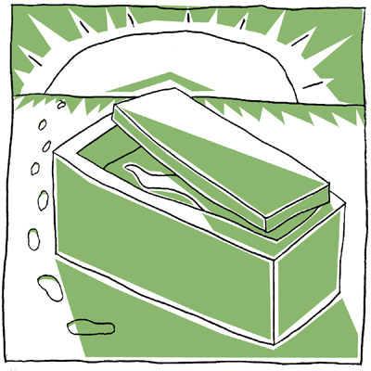

Baptism

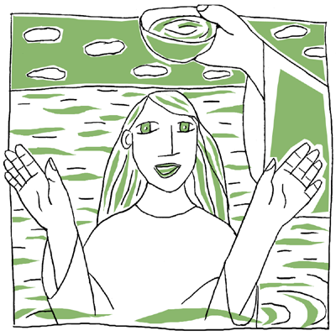

blessing of baptismal water

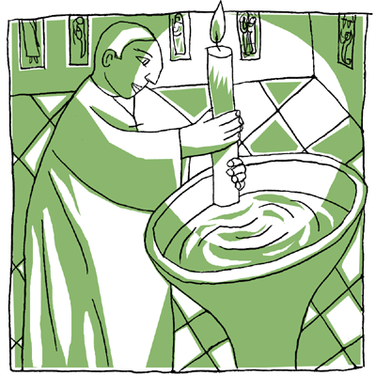
light and fire

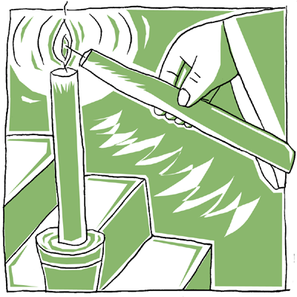

preparing the new Easter candle

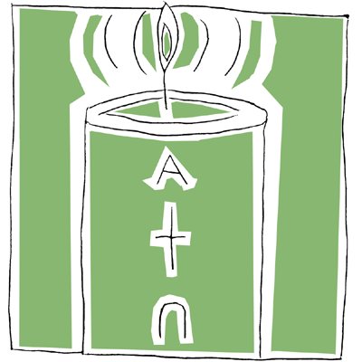

veneration of the cross

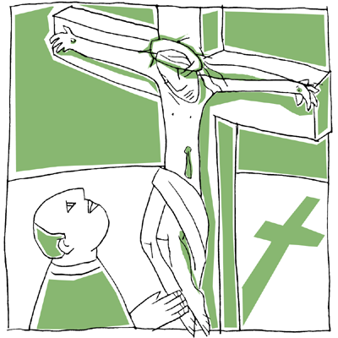

adoration of the Blessed Sacrament

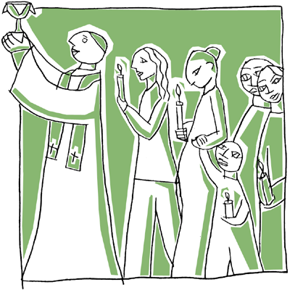

basin and towel

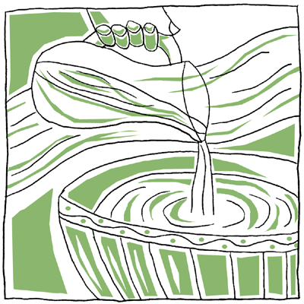

bread and wine

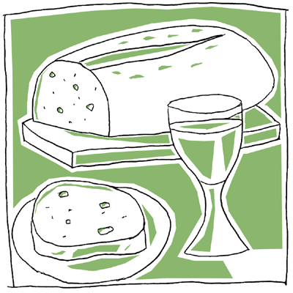

crown of thorns
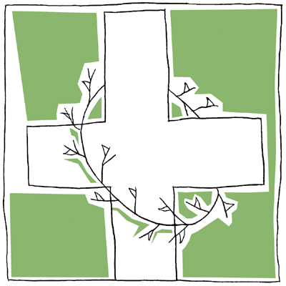

anointing with oil
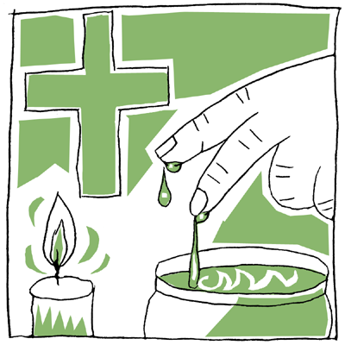

general intercessions for the Church and world
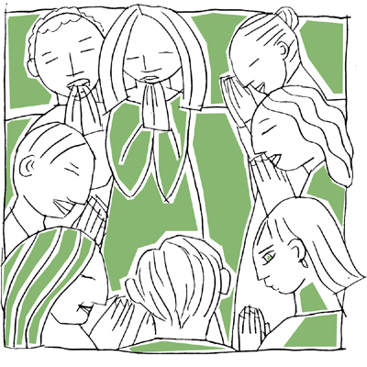

Easter candles – passing the light
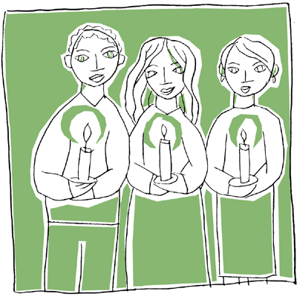

communion with the Body and Blood of Christ

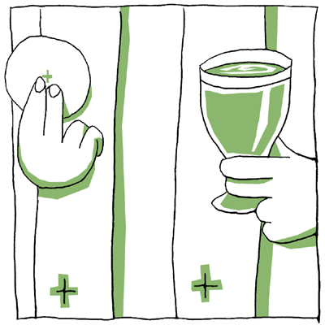
Handout #1A.

Triduum Quiz Worksheet

Test your knowledge of the events, people, symbols, and ritual actions of the liturgies of Holy Thursday, Good Friday, and the Easter Vigil. Each item is found within the Scripture readings and liturgical actions of one liturgy. Using the list below, write the item under the liturgy where you think it belongs.

Events and People

- getting warm by the fire
- story of the crossing of the Red Sea
- the arrest of Jesus
- stone rolled away
- Judas
- procession to Calvary
- Barabbas
- story of Passover
- Mary Magdalene
- Joseph of Arimathea
- soldiers
- finding a room for a meal
- Pontius Pilate judges Jesus
- story of creation
- interrogation at the High Priest’s house

Symbols

- light and fire
- water
- oil anointing
- shared meal
- bread and wine
- cross
- crown of thorns
- white vestments
- red vestments
- basin and towel

Ritual Actions

- washing feet
- veneration of the cross
- preparing the new Easter candle
- communion with the body and blood of Christ
- blessing the fire and lighting candles
- general intercessions for the church and world
- stripping the altar
- celebration of the sacrament of Baptism
- litany of the saints
- adoration of the Blessed Sacrament
- blessing of the baptismal water
- renewal of baptismal promises

Holy Thursday | Good Friday | Easter Vigil

Handout #2.

Good Friday Prayer Service

In the Name of the Father, and of the Son, and of the Holy Spirit,
All: Amen.

Let us pray. (Pause for a moment of silent prayer.)

Loving God, by Jesus’ suffering on the cross,
we know your love and your call to be faithful.
Help us to come to you bravely when we are in need,
and guide us to share your love generously.
We ask this through Christ, our Lord.
All: Amen.

Through Jesus’ cross, word of God’s love spread throughout the world and to all people. This word of love continues to spread. Today, as we remember Good Friday, let us pray with the whole Church that all people will come to know God’s love.

(Holding up the cross, say the following prayer.)

This is the wood of the cross, on which hung the Savior of the world.
Response: Come, let us worship.

As we pass this cross around our circle, let us think of a person or a community of people who need to know the love of God. When you hold the cross, think of who you would like to pray for. We can pray together in silence or you can share your intention aloud.

(The prayer leader begins by holding the cross and taking a moment to pray, aloud or in silence. The leader then passes the cross to the next person. After the cross has been passed around the circle, continue the prayer.)

Let us pray.
As we continue to prepare for Easter by remembering the love and friendship of Jesus,
May the Cross remind us to follow Jesus’ love.
Lord, open our hearts to share with others,
And lead us to your joy, love, and compassion.
All: Amen.

Close by sharing a sign of peace with each other.

Triduum Readings and Symbols

Liturgy | Readings | Symbols and Meanings
Holy Thursday | Exodus 12:1-8, 11-14  1Corinthians 11:23-26  John 13:1-15 | Water  - washing feet as a sign of service and self-sacrificing nature of Jesus’ love  Shared Meal  - Jesus’ everlasting presence—the Eucharist  - sharing in the saving effects of Jesus’ sacrifice: his paschal mystery, his death and resurrection  - giving thanks and praise  Bread  - Jesus feeds us, fills our hunger  - the body of Christ, broken for us  - strength to take up the cross and live the Gospel—to become bread for the world  Wine  - Jesus quenches our thirst  - the blood of Christ, given for us  - the new covenant
Good Friday | Isaiah 52:12-53  Hebrews 4:14-16; 5:7-9  John 18:1—19:42 | Cross  - crucifixion  - suffering and pain  - sacrifice of Jesus, giving one’s life for one’s friends  - death as the instrument of salvation  Thorns  - suffering and pain  - crown of the suffering Messiah
Easter Vigil | Genesis 1:1-2 and 2  Genesis 22:1-18  Exodus 14:15—15:1  Isaiah 54:5-14  Isaiah 55:1-11  Baruch 3:9-15, and 3:32—4:4  Ezekiel 36:16-28  Romans 6:3-11  Matthew 28:1-10  Mark 16:1-8 (B)  Luke 25:1-12 (C) | Light and Fire  - Christ’s presence  - new life in Christ  - Christ, the light, overcomes the darkness of sin  - resurrection, victory over death  - reverence and a sign of a joyous celebration  Water  - Baptism  - cleansing from sin, purification  - new life emerges from the water—resurrected life  - incorporation into Christ’s death and resurrection  Oil and Anointing  - our need for God’s help and strength  - spiritual strength, receiving God’s grace  - empowered for mission as a follower of Jesus  - healing and comfort (Anointing the Sick)  - sealed with the gift of the Holy Spirit  - bonding us to the person of Jesus Christ
Easter Sunday | Acts 10:34, 37-43  Colossians 3:1-4 or 1Cor 5:6-8  John 20:1-9

